**NimbusAI: Singularity**

**Version-PSS**

User Manual

Table of Contents

Introduction 3

Getting Started 3

Installation 3

Accessing the Application 3

Interface 4

Interface Overview 4

Full Interface 4

Left Panel (Chat Interface) 4

Right Panel (Visualization Interface) 5

Uploading and Analyzing Data 6

Understanding the Pipeline 8

Interacting with Visualizations 10

Show final data command shows comprehensive graph 11

Viewing Raw Data 11

Asking Questions About Your Data 12

Downloading Results 13

Troubleshooting 14

Common Issues 14

System Requirements 14

Supported Browsers 14

Device Requirements 14

Security and Data Privacy 15

Technical Support 15

# 

# Introduction

Welcome to Nimbus AI-PSS (Plot-Salt-Smooth-Graph), an enterprise-grade data analysis and visualization platform designed for financial time series analysis. Nimbus AI-PSS applies a sophisticated processing pipeline to your data, enhancing patterns and reducing noise to reveal insights that might otherwise remain hidden.

Our proprietary Plot-Salt-Smooth-Graph pipeline transforms raw data through a sequence of carefully calibrated operations, each designed to enhance key features while minimizing noise. This approach is particularly valuable for analyzing stock market data, financial metrics, and other time series information where pattern recognition is essential.

# Getting Started

Installation

Nimbus AI-PSS is available as both a web application and a locally deployable solution. This guide focuses on the web application version, which requires no installation.

Accessing the Application

1. Navigate to your company's Nimbus AI-PSS URL in a modern web browser
2. Log in using your corporate credentials (if applicable)
3. You will be presented with the main interface shown below: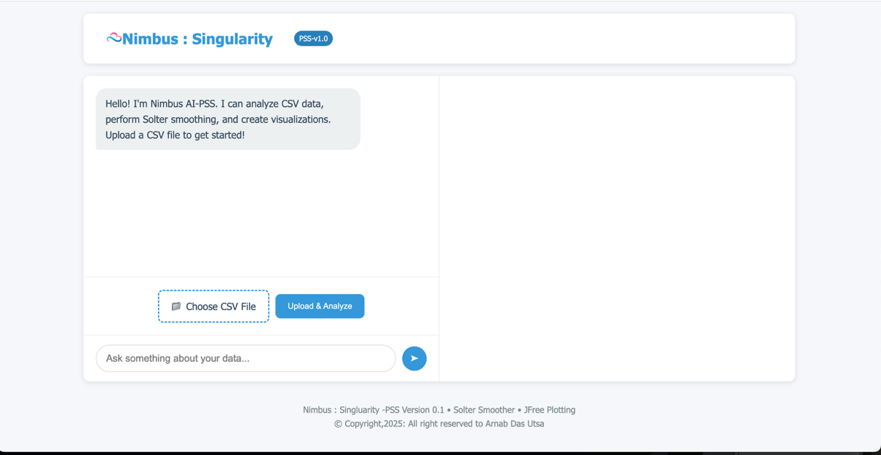

Interface

# Interface Overview

The Nimbus AI-PSS interface is divided into two main sections: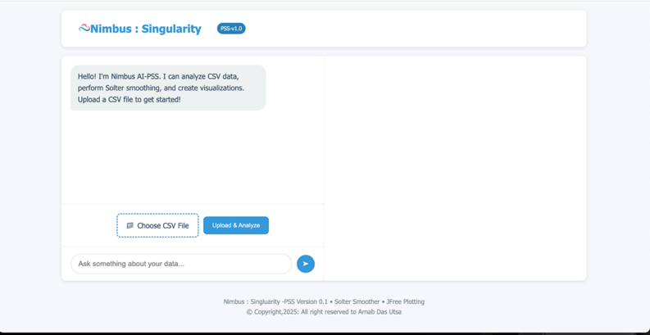

Full Interface

Left Panel (Chat Interface)

* Header: Displays the Nimbus AI-PSS logo and version
* Chat Area: Shows your conversation with the AI assistant
* File Upload: Allows you to select and upload CSV files
* Input Field: Where you type questions or commands
* Send Button: Submits your questions to the AI assistant

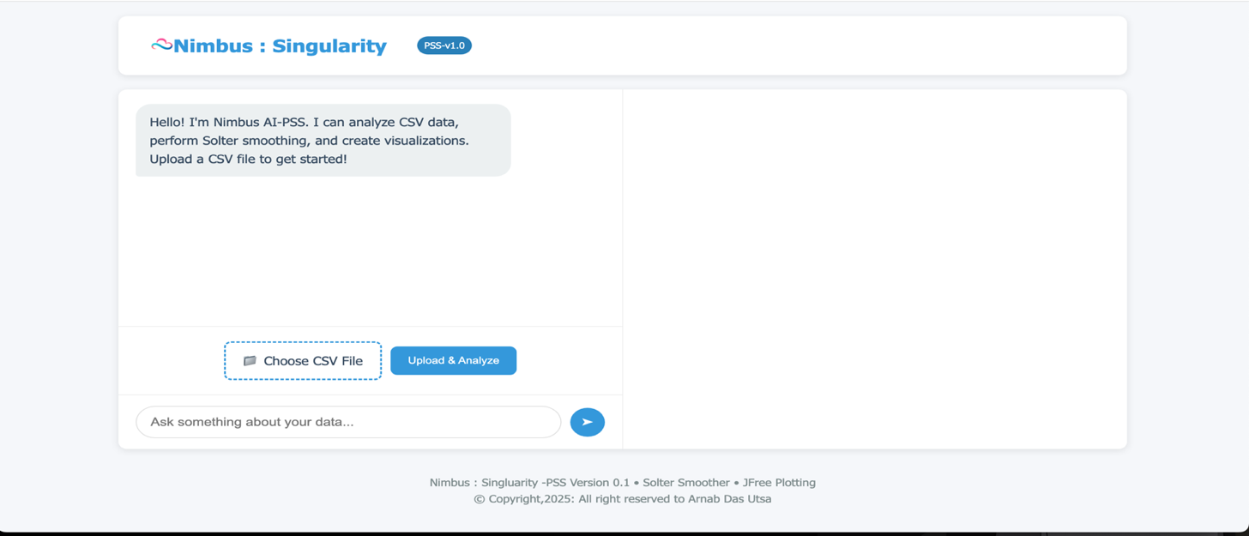

Left Panel

Right Panel (Visualization Interface)

* Visualization Title: Indicates the type of visualization being displayed
* Chart Area: Shows the graphical representation of your data
* Control Buttons: Options to download plots and view raw data
* Data Table: Displays tabular data when requested

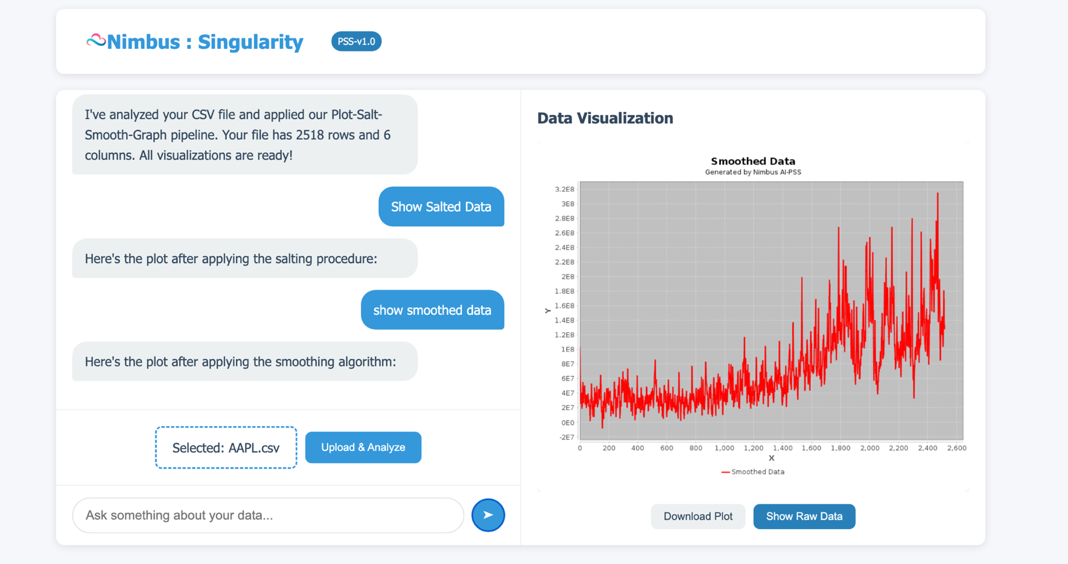

Right Panel

# 

# Uploading and Analyzing Data

To begin analyzing your data:

1. Select a CSV file by clicking on "Choose CSV File" or by dragging and dropping a file 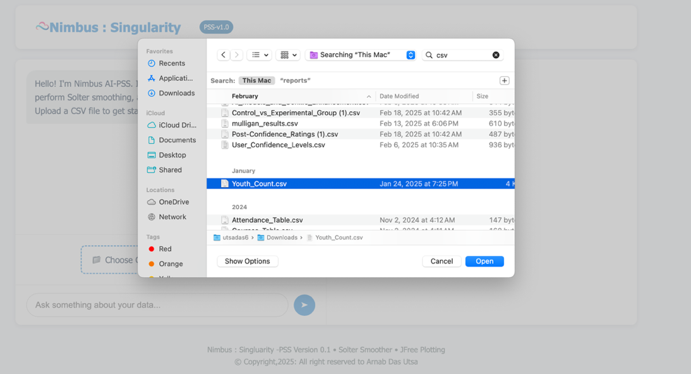

Choosing CSV file

1. Once selected, your chosen file name will appear:
2. Click "Upload & Analyze" to begin processing The system will display a progress: 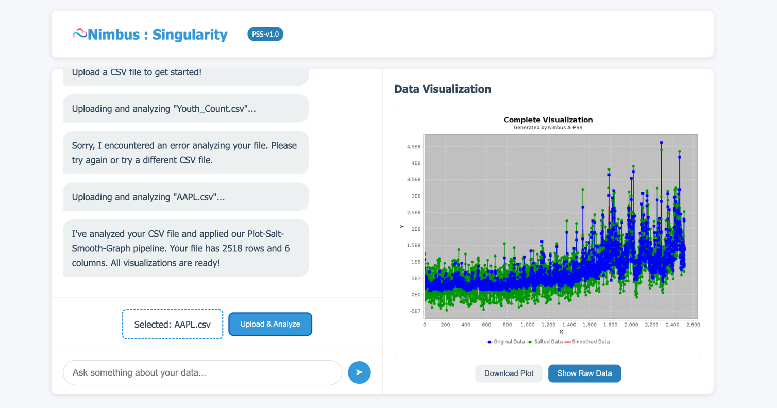

Upload and Analyze button will analyze the csv data

1. After processing completes, you will see a confirmation message with file statistics: 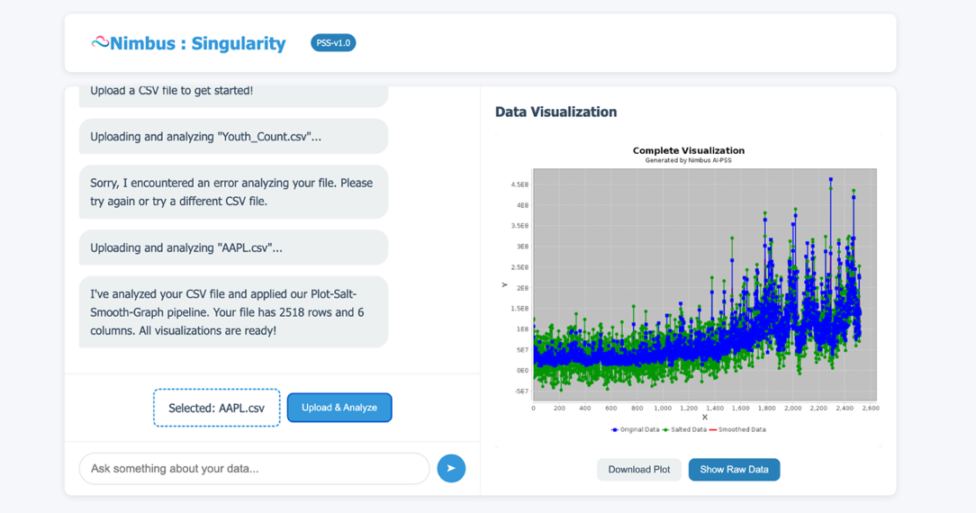
2. The first visualization will automatically appear in the right panel

# Understanding the Pipeline

Nimbus AI-PSS processes your data through four sequential stages:

1. Plot: Initial visualization of raw data

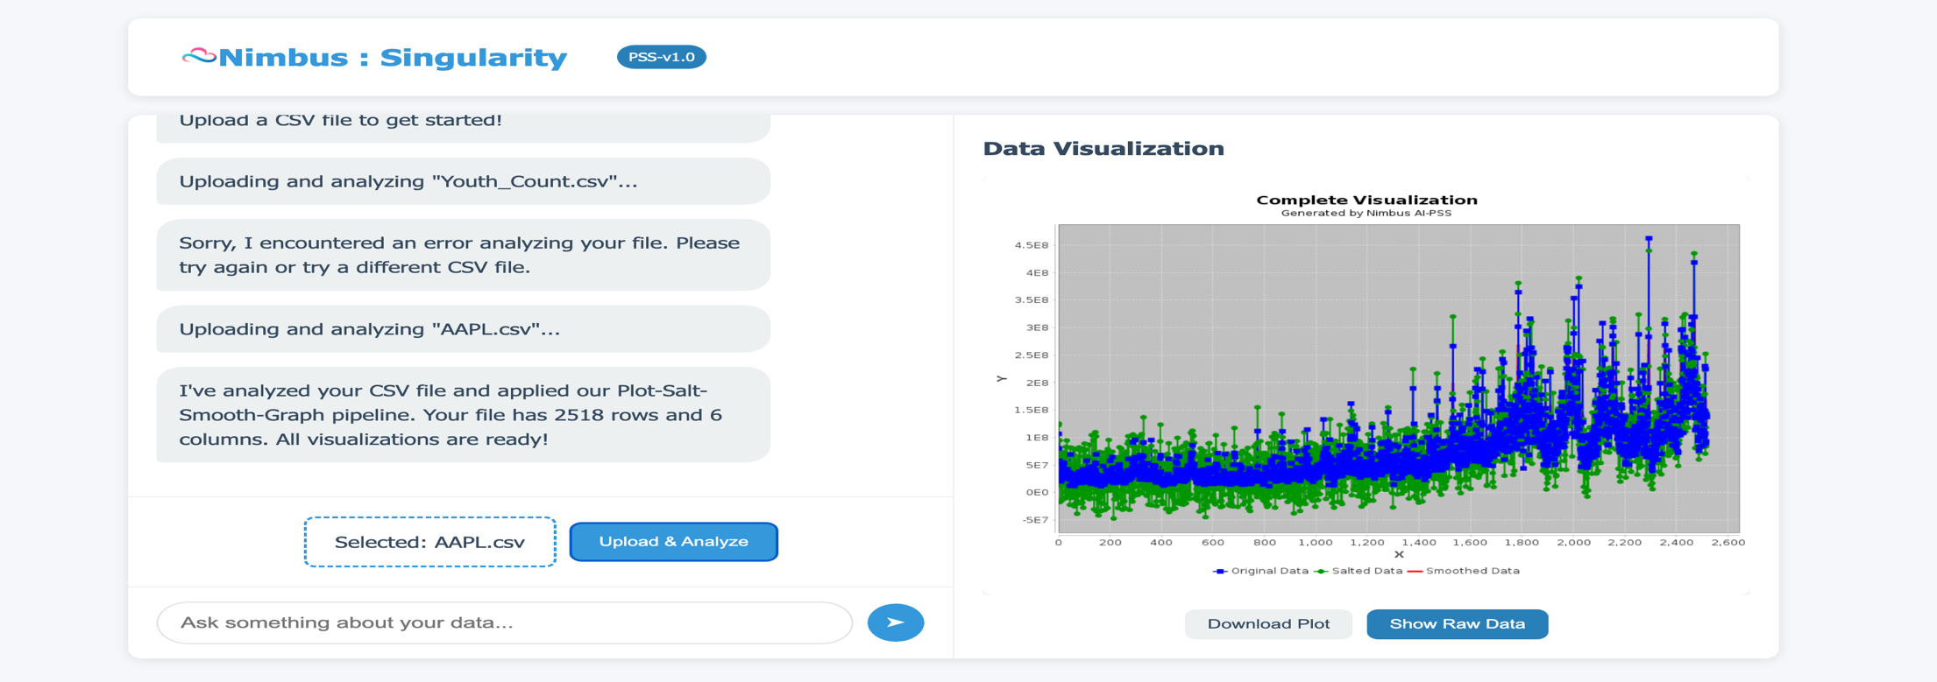

Initial Visuals after AI automatically does with jfree

1. Salt: Application of controlled variability to highlight patterns

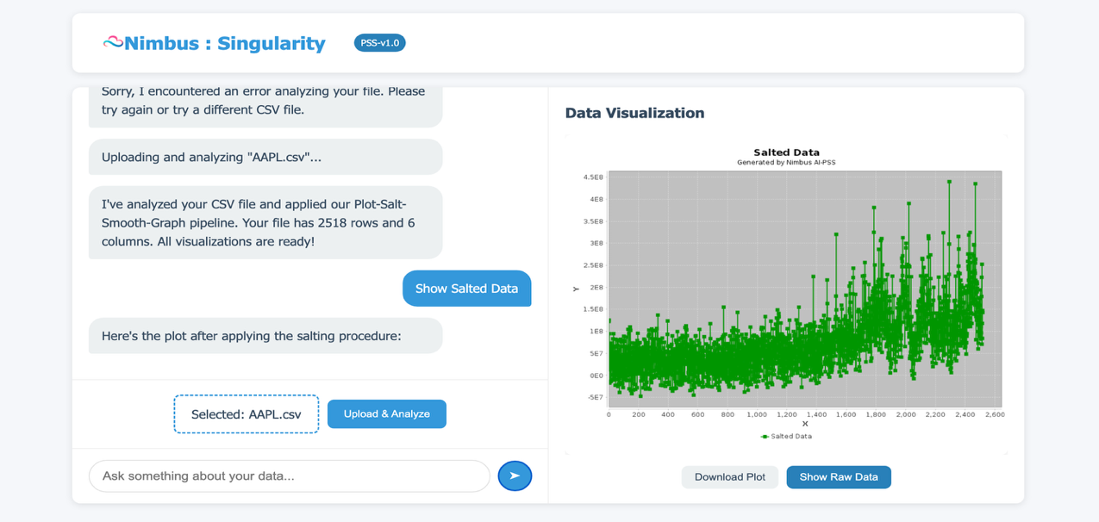

Command to salt data shows salted data

1. Smooth: Application of the Solter smoothing algorithm to reduce noise

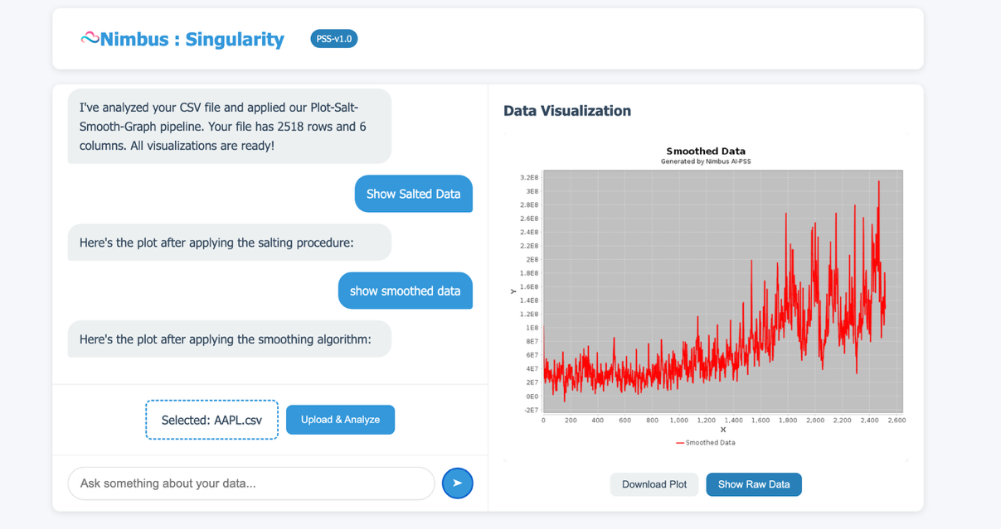

Command to Smooth Data shows smoothed data

1. Graph: Final comprehensive visualization showing all stages for comparison

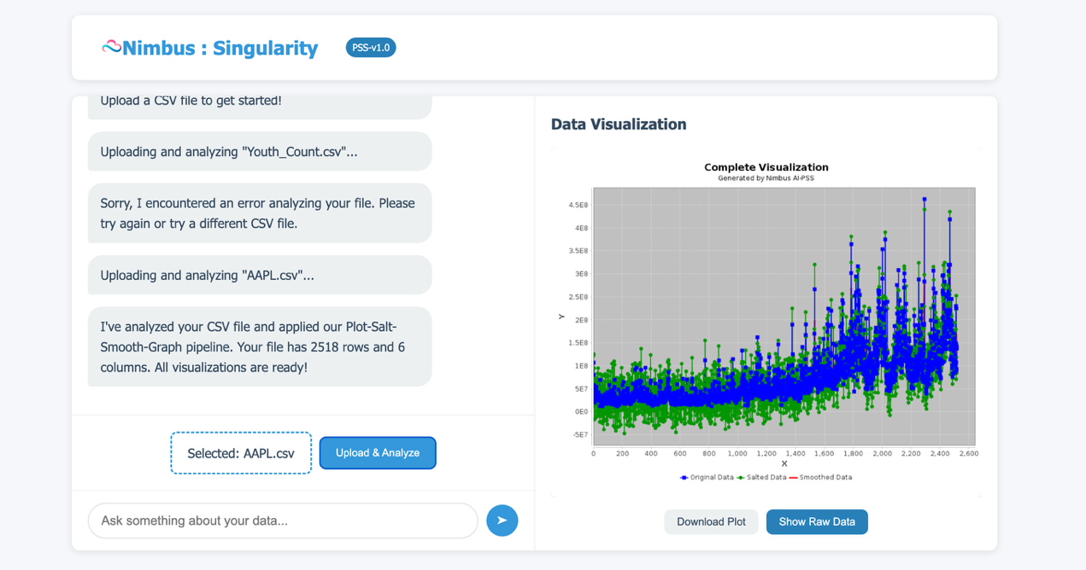

Final Comprehensive Data

Each stage builds upon the previous, creating a progressive enhancement of your data's most significant features.

# Interacting with Visualizations

You can request different visualizations by asking the AI assistant:

* To see the original data plot: Type "Show original data" or click the corresponding button
* To see the salted data plot: Type "Show salted data" or click the corresponding button
* To see the smoothed data plot: Type "Show smoothed data" or click the corresponding button
* To see the complete visualization: Type "Show final graph" or click the corresponding button

Example:

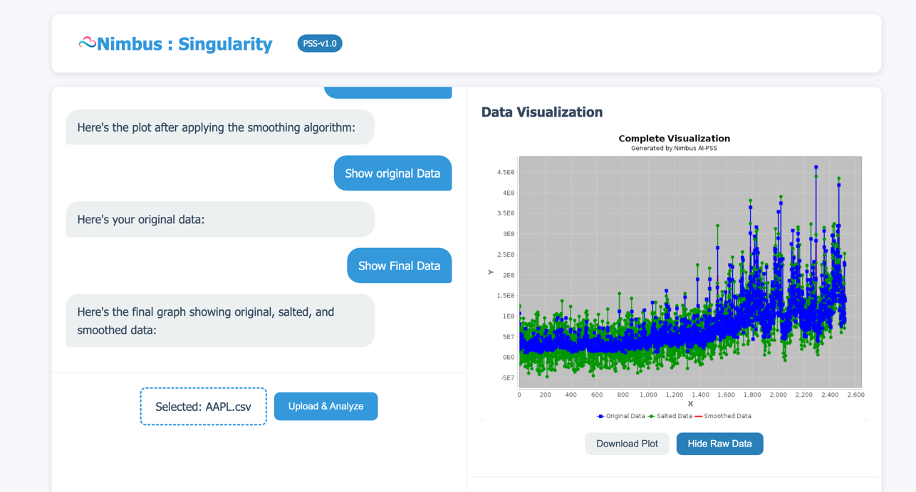

Show final data command shows comprehensive graph

# Viewing Raw Data

To examine the tabular data behind the visualizations:

1. Click the "Show Raw Data" button below any visualization
2. The raw data table will appear below the visualization:

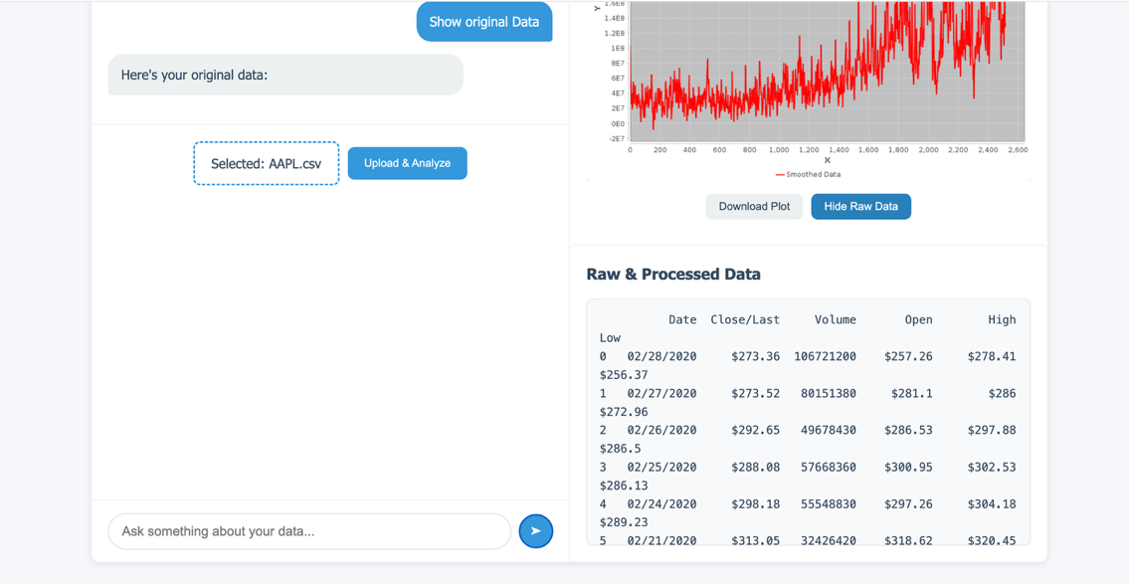

The raw data table displays

* Date information
* Numeric values
* Original and processed data points

To hide the raw data, click "Hide Raw Data".

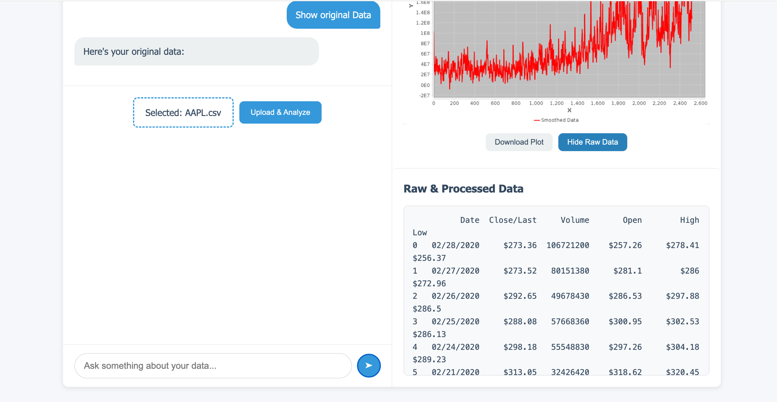

Hide row data

# Asking Questions About Your Data

You can ask the AI assistant questions about your data by typing in the input field:

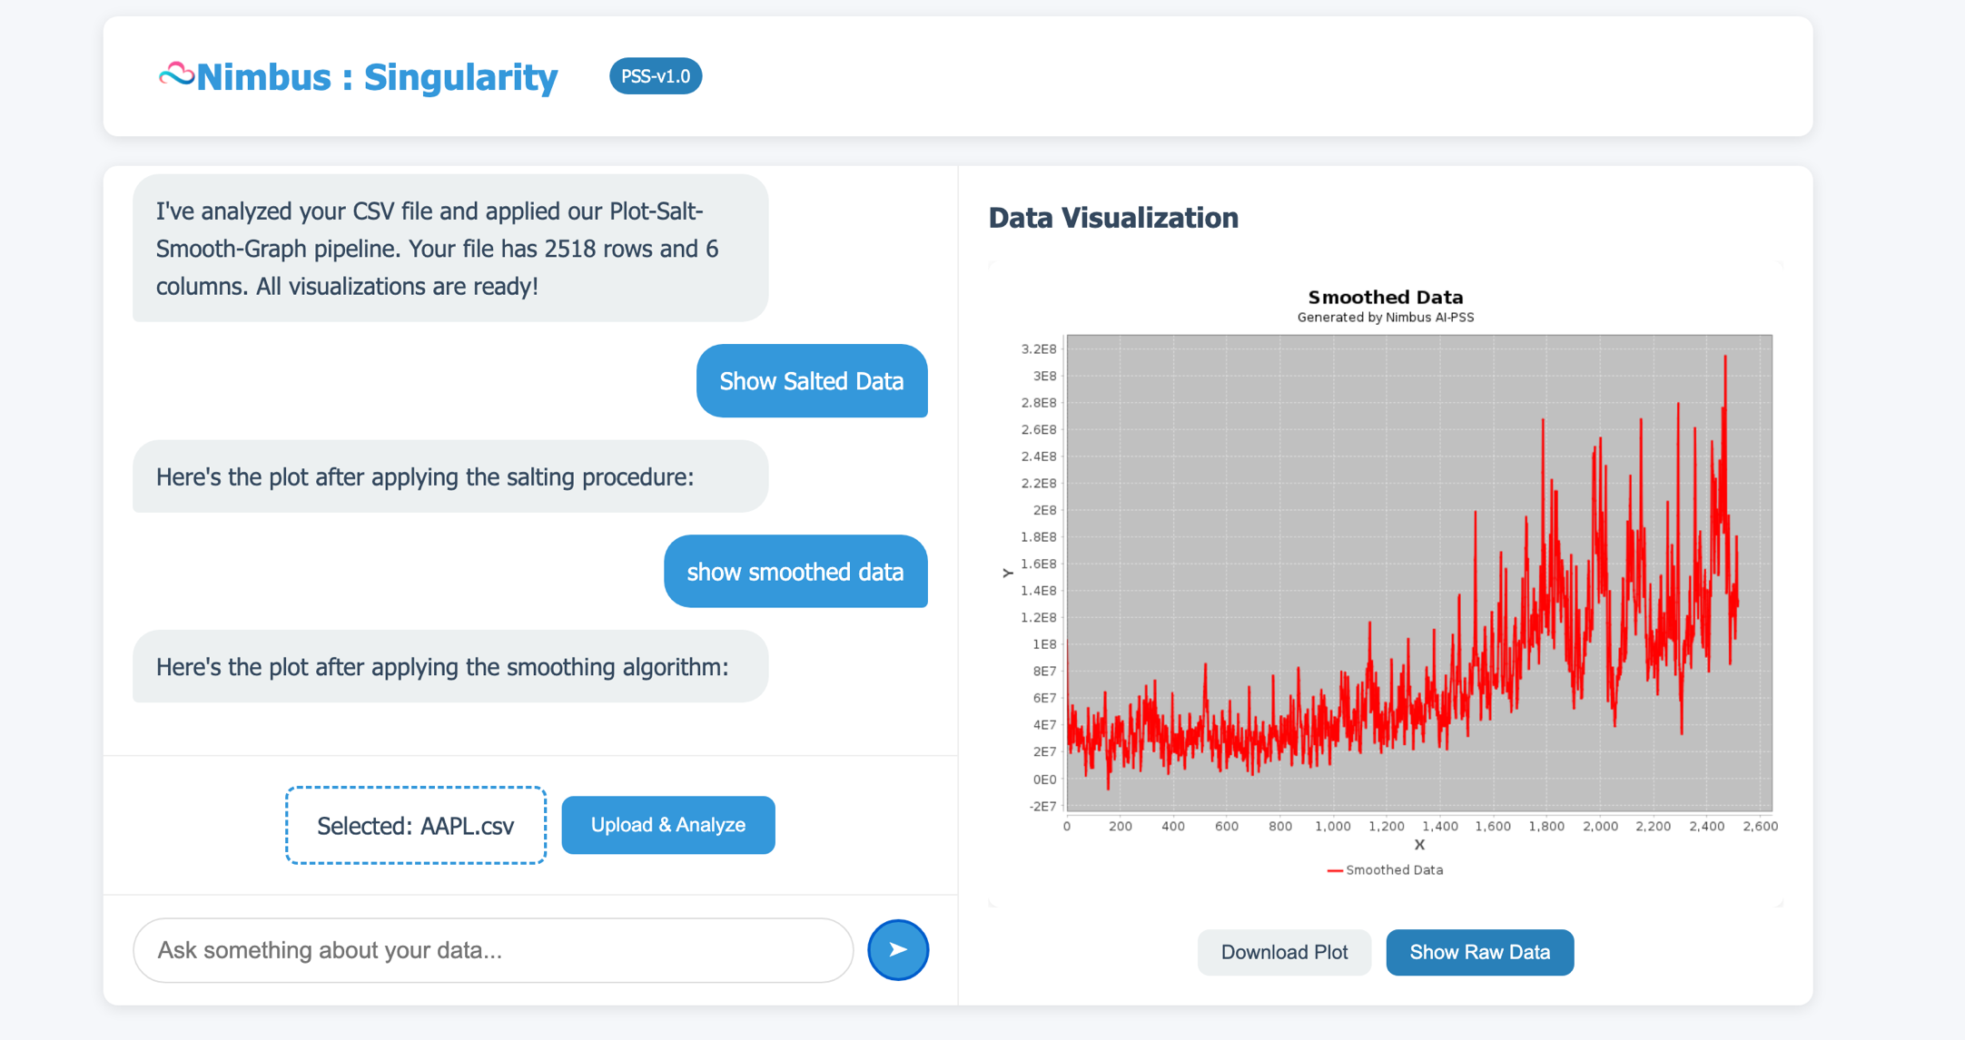

Input Panel

Example questions you can ask:

* "Explain the salting procedure"
* "Explain the smoothing algorithm"
* "Tell me about my data"
* "What trends do you see in this stock data?"
* "Explain the Plot-Salt-Smooth-Graph pipeline"

The AI will respond with informative answers based on your specific data.

# Downloading Results

To save your results:

1. Click the "Download Plot" button below any visualization
2. The current visualization will be saved as a PNG image to your downloads folder
3. For raw data, you can copy and paste from the data table into a spreadsheet application

# Troubleshooting

Common Issues

File Format Errors

Ensure your CSV file:

* Has a .csv extension
* Contains properly formatted data
* Has at least one column of numeric data
* Doesn't contain corrupt or improperly formatted data

Data Not Displaying

If visualizations don't appear:

1. Check that your CSV contains numeric time series data
2. Try uploading a different CSV file
3. Refresh the browser and try again

# System Requirements

Supported Browsers

* Google Chrome (version 80+)
* Mozilla Firefox (version 75+)
* Microsoft Edge (Chromium-based, version 80+)
* Safari (version 13+)

Device Requirements

* Minimum screen resolution: 1024x768
* Recommended: 1920x1080 or higher
* Internet connection: 1 Mbps or faster

# Security and Data Privacy

Nimbus AI-PSS prioritizes data security:

* All data is processed on secure servers
* Files are not stored permanently after analysis
* No data is shared with third parties
* Session information is encrypted

# Technical Support

For assistance with Nimbus AI-PSS:

* Email: utsa.arnab@gmail.com

© Copyright 2025: All rights reserved to Arnab Das Utsa

Nimbus : Singularity -PSS Version 0.1 • Solter Smoother • JFree Plotting